**BMF Progress Report**

**Understanding Project Data Structure**

Since this project will focus on projects at BMF, understanding project structure is a key step before designing the dashboard. Projects are tracked using KPI’s targets, which is what will be used to create visual analytics for the dashboard.

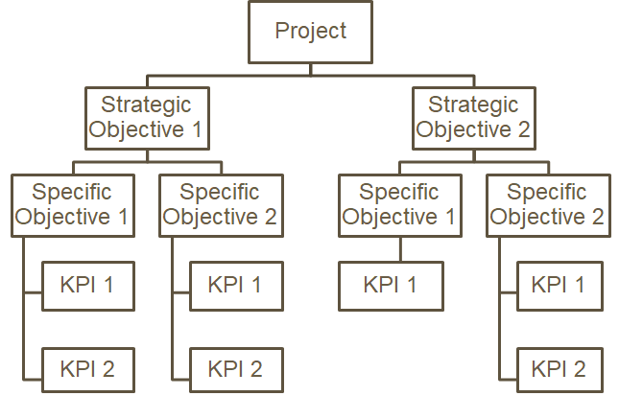

**Database Schema Design**

**Dashboards Mockup design**